QUICK AND DIRTY SHIELD TUTORIAL
FIrst a few setup things
1)make sure the model to be shielded has a hardpoint at {x,y,z} = {0,0,0} and no rotation (everything should be zero.
you can duplicate a weapon hardpoint and modifiy it into a normal hardpoint by deleteing the latitude and muzzle nodes and renaming it to something like 'Hardpoint_Shield_Position, Hardpoint_Shield_DIrection, Hardpoint_Shield_Rest... etc)
2)make a subsystem directory called < YOURSHIPNAME >_Shield and make appropriatly named blank text files for the .events and .subs (we will fill those in shortly)
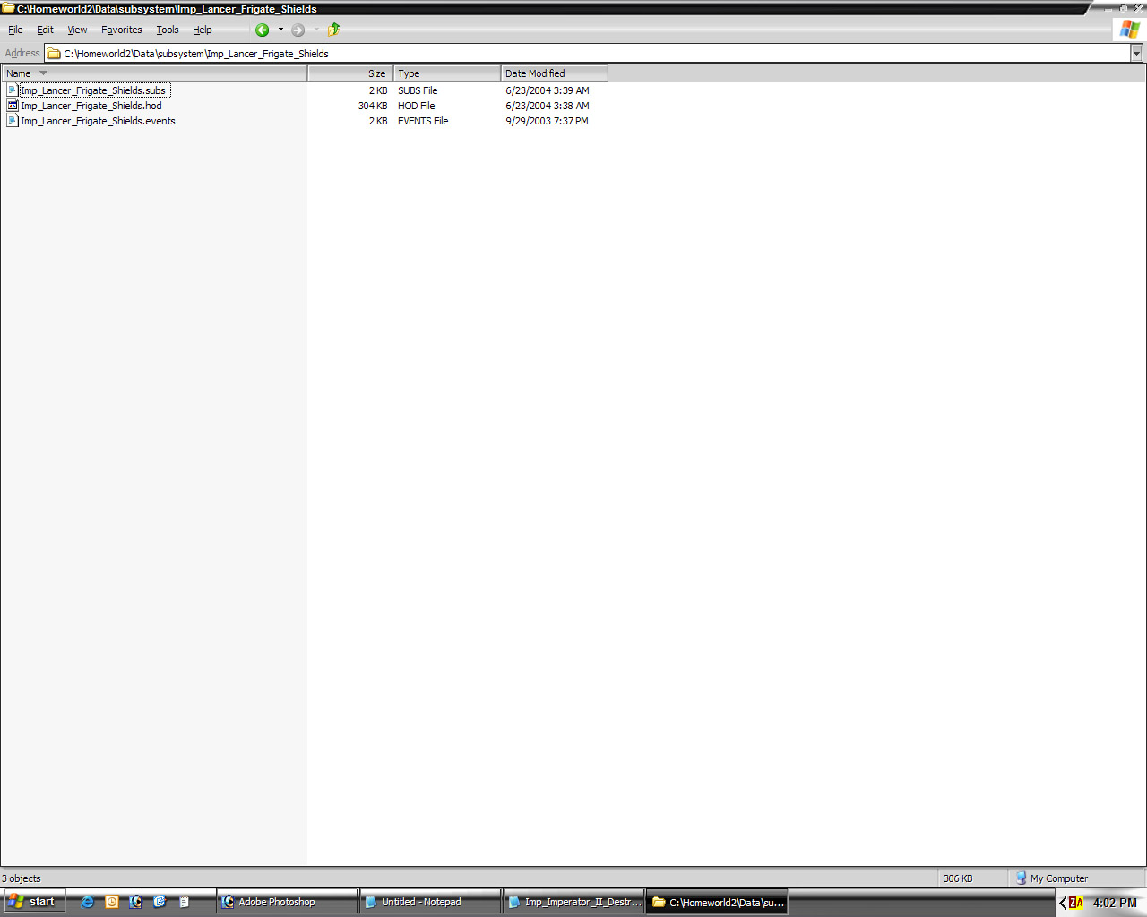
3)In you ship file add the line
StartShipHardPointConfig(NewShipType,"Shield","Hardpoint_Shield","System","Innate","Damageable","< YOUR-SHIELD-SUBS-FILENAME-HERE >","","","","","","","","")
this must come after the loadmodel() or loadsharedmodel line, otherwise you will get a crash on loading that will give no error.
this is the format for th line above StartShipHardPointConfig(NewShipType,"< ARBITRATY NAME >","< HARPOINT TO MOUNT SUB TO >","< TYPE, CAN BE WEAPON OR SYSTEM >","< INATE OR BUILABLE, UPGRaDABLE >","< DESTROYABLE OR DAMAGABLE >","< YOUR-SHIELD-SUBS-FILENAME-HERE >","","","","","","","","")
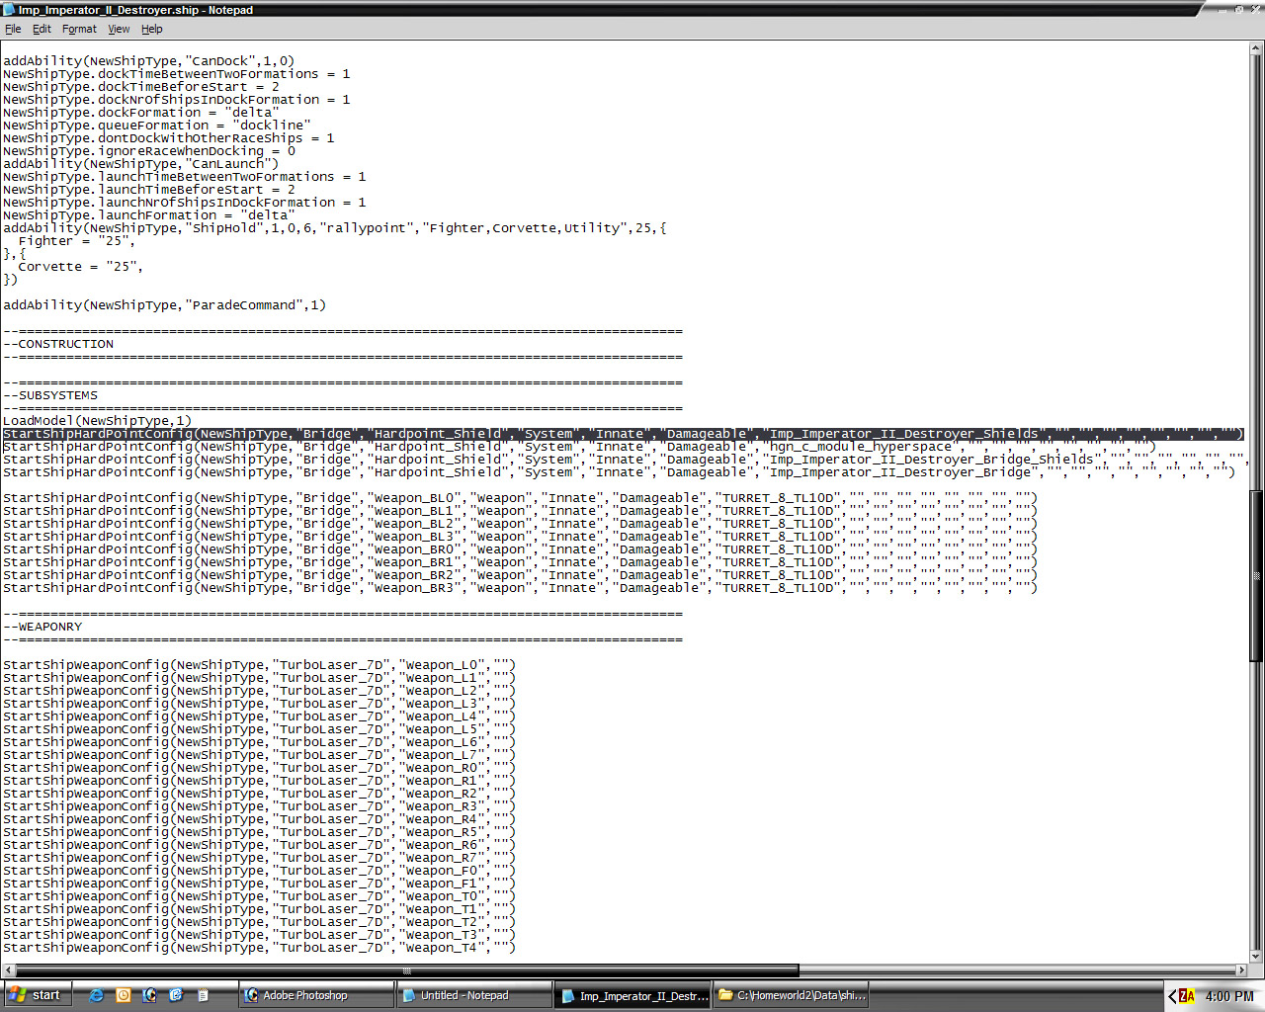
4) using whatever graphics application you make your textures in, make a 2x2 texture (it doesn't matter what it looks like, it will be invisible anyway) and make a $diffuse and $glow channel as you would normally make for a HW2 ship texture
now I use 3DS max for all of my modelling so the operations below should be similar to what I am doing here (just clone, scale, and move vertices)
1) take the LOD0 model of your ship and clone it, probably naming it SHIELD_MESH or similar.
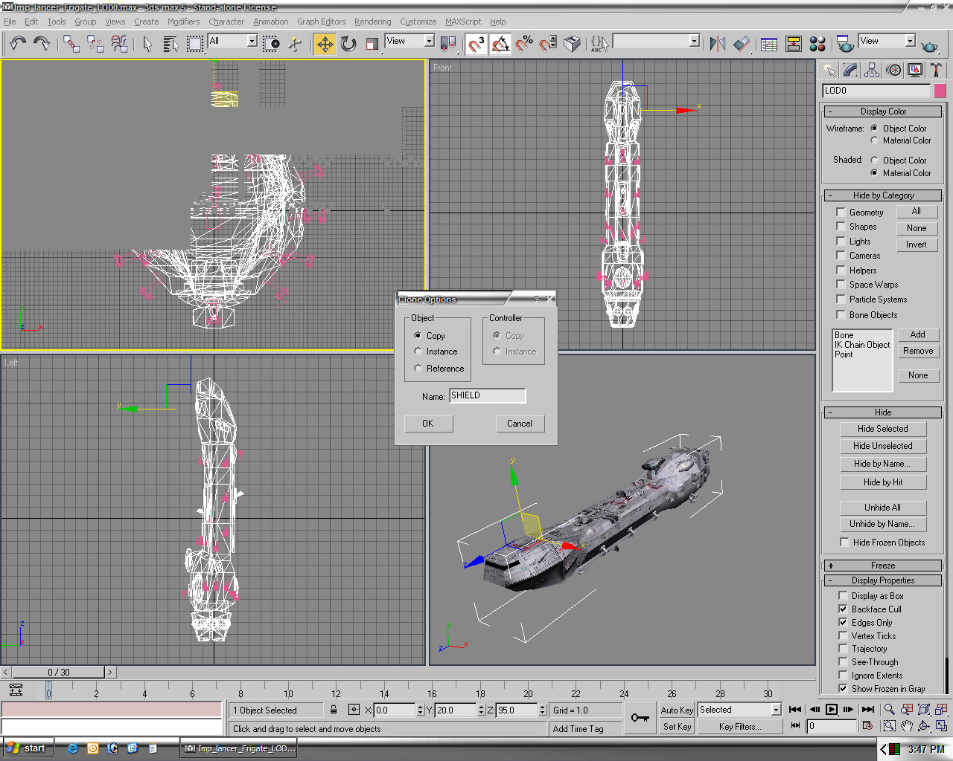
2) remove any extra polys that you don't want shielded (antenna or turrets)
3) scale the sheild mesh by a very small amount, maybe 1% larger than the original mesh (this will be explained at the end of the tutorial)
4) for visibilty I usually make the shield mesh a different color so that it stands out against the LOD0 mesh, at this point inspect the shield mesh and see if it covers every part of the ship you want shielded (any place you see the origianl mesh will impact the hull and not the shield), but you don't have to be absolutely perfect
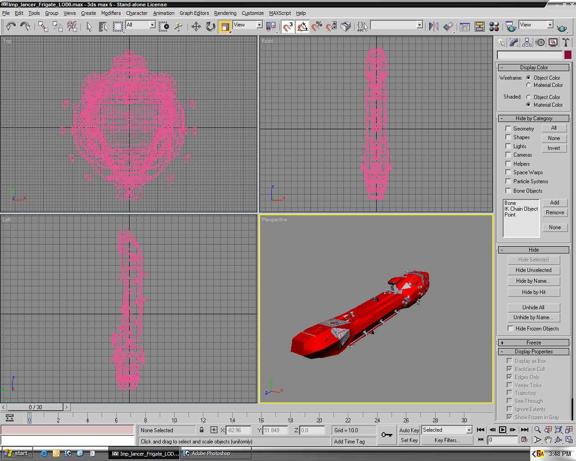
5) move any faces or vertices you need to cover up the underlying mesh
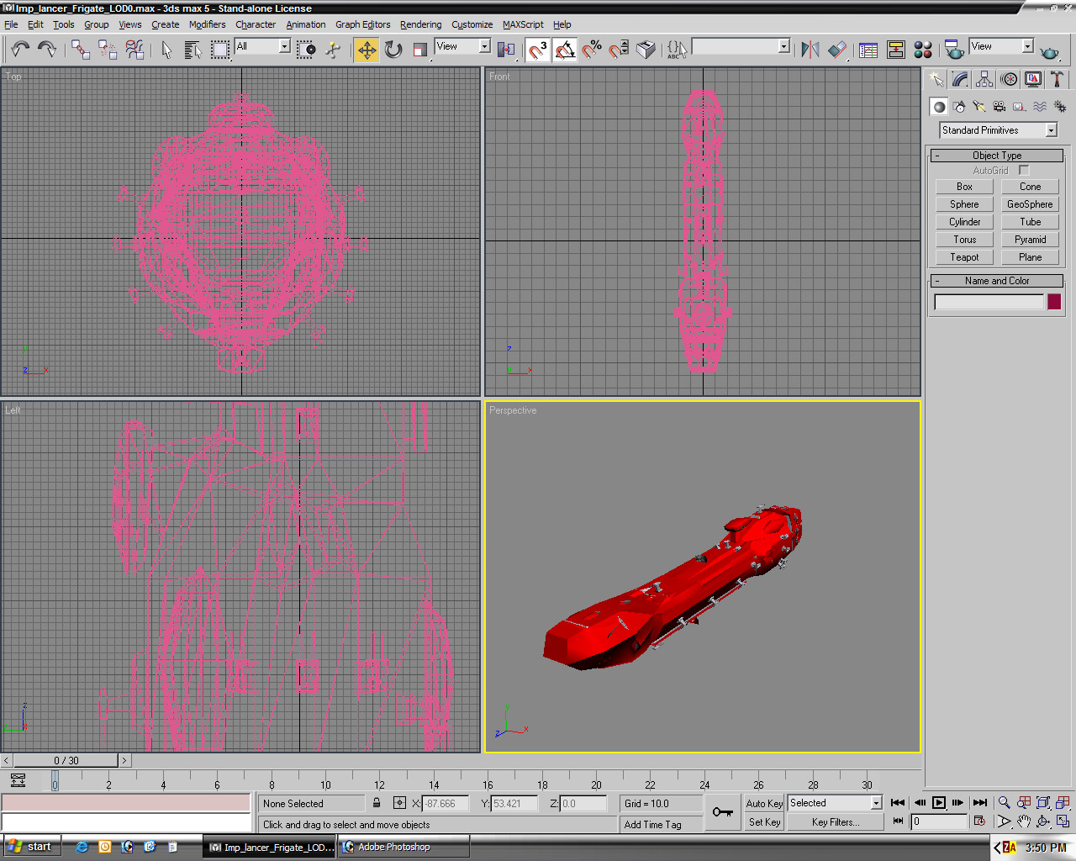
6) if you are modelling outside of maya, you should export the shield mesh, otherwise continue on
7) open up maya if you weren't using it before and take a exisitng HW2 ship and resave it as a file that is named so that you can recognize it as a shield for the ship.
8) load in your 2x2 dummy texture in a HW2shader and delete any extraneous shaders or shading groups that may have been from the last ship
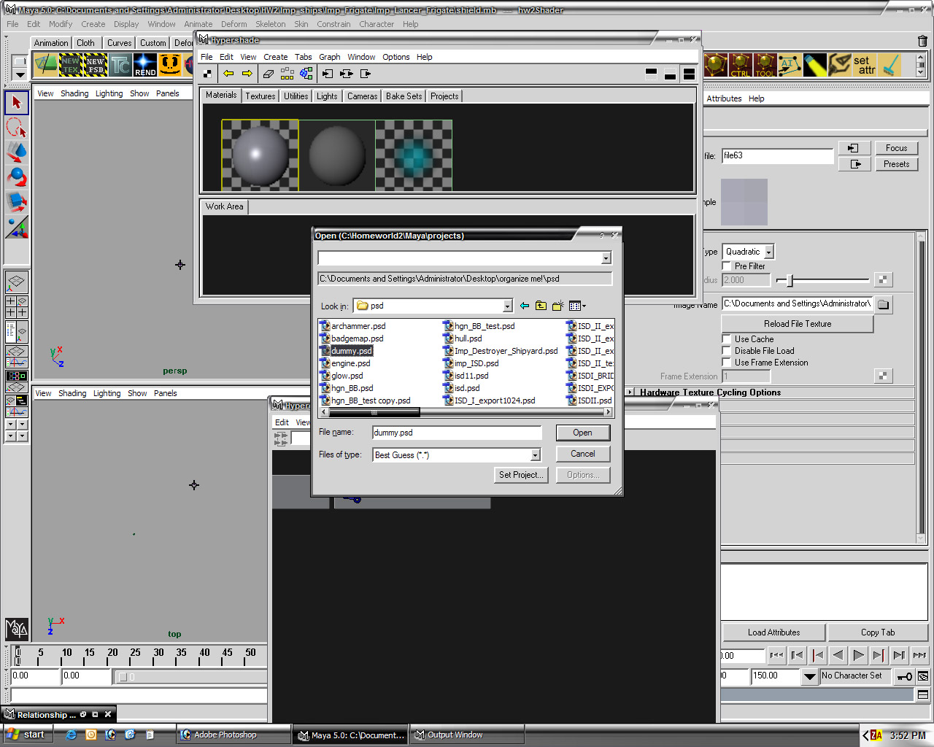
9) delete any and all geometry and nodes on the hyper graph, you should be left with just the root and the cameras
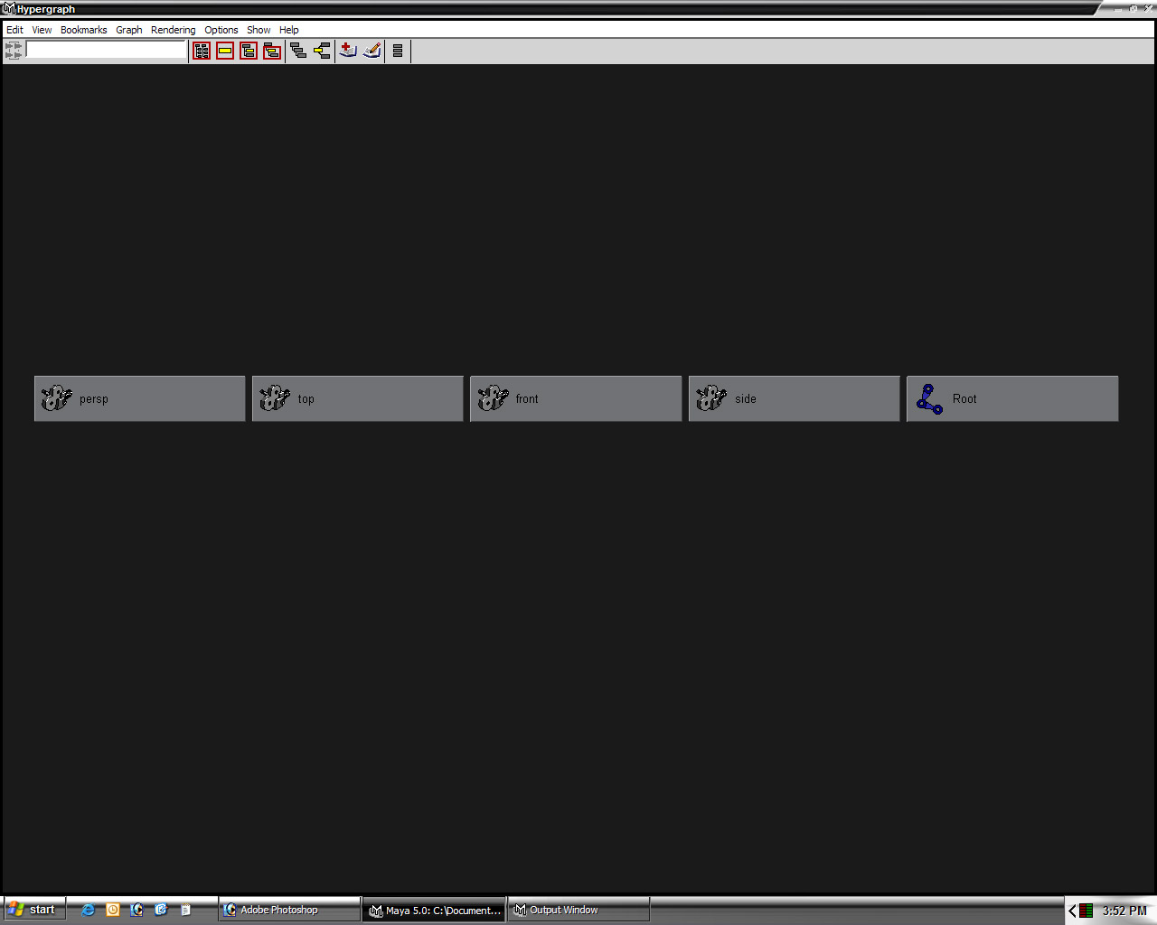
10) import your shield mesh twice (or clone it if you are in maya) name the first one SHIELD_LOD0 and the second one CM_X (naming it somehting different like CM_SHIELD seems to cause a file error when loading subsequent times) parent under the root
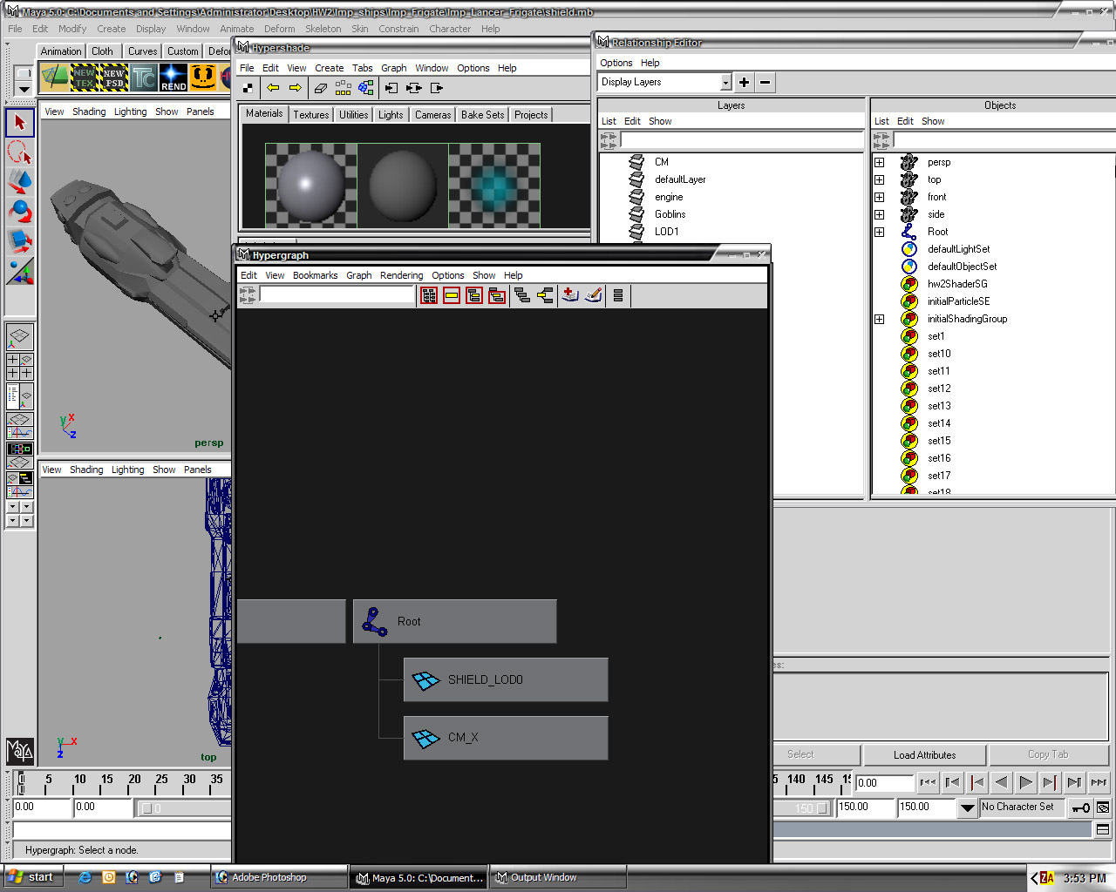
11) assign the SHIELD_LOD0 to the ship layer and the CM_X to the CM layer
12) apply the dummy texture to the shieldmesh
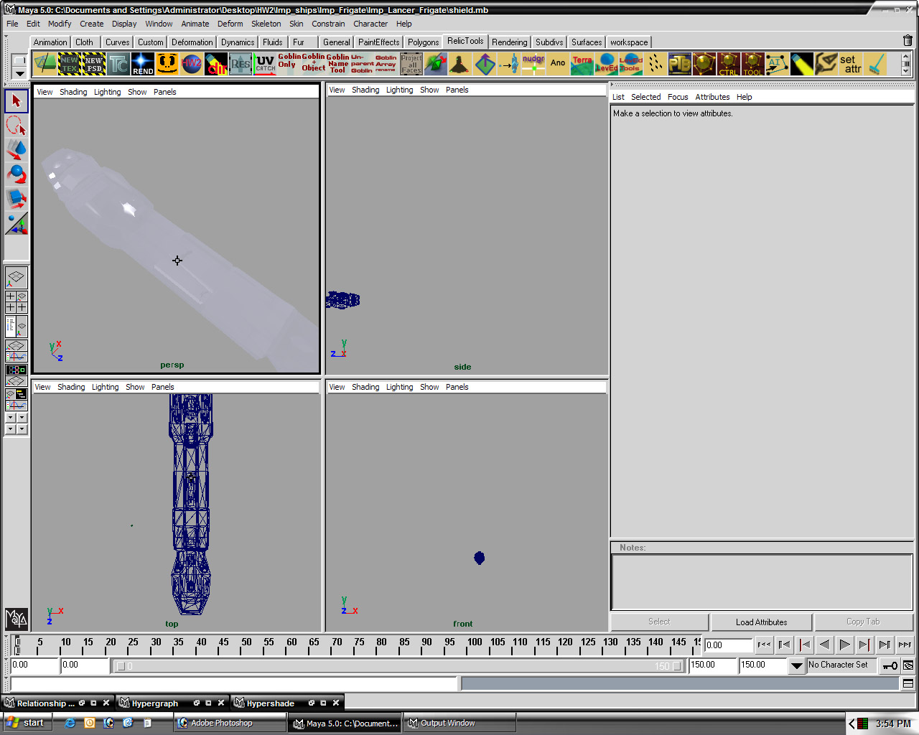
13) export the sheild as you would normally export a ship hod, except put it into you subsystem directory
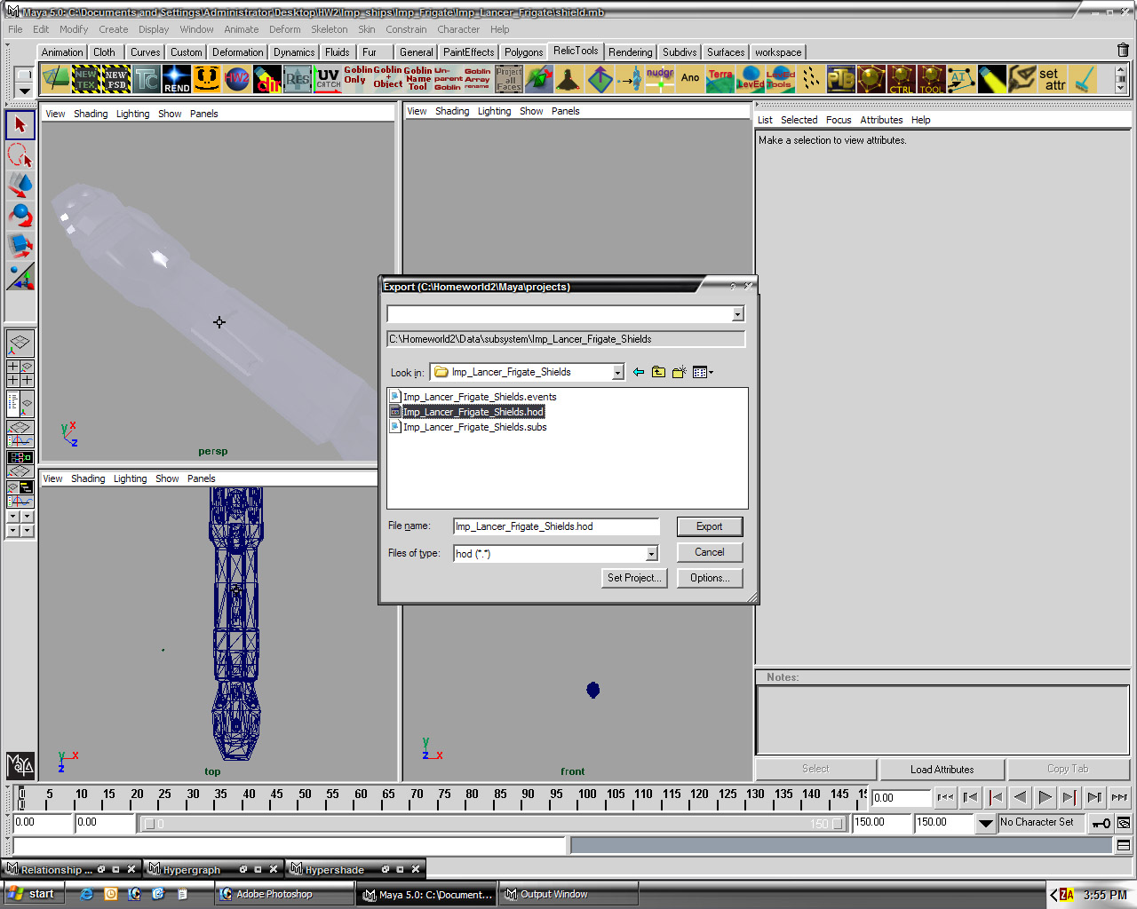
now on to the subsystem files
1) the .events file I usually leave blank, but you can edit this as you wish if you want extra effects.
2) in the .subs file paste the following code
NewSubSystemType = StartSubSystemConfig()
NewSubSystemType.displayedName = "Shield"
NewSubSystemType.sobDescription = "Shield"
NewSubSystemType.tacticalIcon = "hexagon"
NewSubSystemType.tacticalIconMinSize = 0.0035
NewSubSystemType.tacticalIconMinFadeSize = 0.0045
NewSubSystemType.tacticalIconMaxFadeSize = 0.008
NewSubSystemType.groupMergeSize = 0
NewSubSystemType.mouseOverMinFadeSize = 0.045
NewSubSystemType.mouseOverMaxFadeSize = 0.1
NewSubSystemType.maxhealth = 14875
NewSubSystemType.regentime = 35
NewSubSystemType.nlips = 0
NewSubSystemType.nlipsRange = 0
NewSubSystemType.nlipsFar = 0
NewSubSystemType.nlipsFarRange = 0
NewSubSystemType.meshRenderLimit = 0.001
NewSubSystemType.minimumZoomFactor = 0.6800000000000001
NewSubSystemType.selectionLimit = 20000
NewSubSystemType.preciseSelectionLimit = 1000
NewSubSystemType.preciseATILimit = 5000
NewSubSystemType.selectionPriority = 0.5
NewSubSystemType.type = "Shield"
NewSubSystemType.typeString = "Shield"
NewSubSystemType.collateralDamage = 0
NewSubSystemType.inactiveTimeAfterDamage = 26
NewSubSystemType.activateHealthPercentage = 0.1
NewSubSystemType.healthBarStyle = 1
NewSubSystemType.costToBuild = 0
NewSubSystemType.timeToBuild = 0
NewSubSystemType.isResearch = 0
NewSubSystemType.visible = 0
NewSubSystemType.innate = 1
LoadHODFile(NewSubSystemType,1)
NewSubSystemType.BuildFamily = "SubSystem_Hgn"
NewSubSystemType.AttackFamily = "Frigate"
NewSubSystemType.DockFamily = "CantDock"
NewSubSystemType.DisplayFamily = "SubSystemModule"
NewSubSystemType.ArmourFamily = "SubSystemArmour"
the important lines are:
this line defines the total health of the shield
NewSubSystemType.maxhealth = 14875
this line sets to total recharge time of the shield, keep in mind that this is really damage absorbtion or maxhealth/regentime damage absorbed per second (calibrate to your weapons, otherwise the shield will be invincible)
NewSubSystemType.regentime = 35
set the following three to zero if you don't want to be appraised of the sheild haelth through the ATI
NewSubSystemType.selectionLimit = 20000 NewSubSystemType.preciseSelectionLimit = 1000 NewSubSystemType.preciseATILimit = 5000
this value sets how long the shield will be down and not recharging once its health is depleated
NewSubSystemType.inactiveTimeAfterDamage = 26
this is the health percentage where the shield reactivates after charging (so it has to be inactive as above and then recharge to this fraction before it absorbs damage again)
NewSubSystemType.activateHealthPercentage = 0.1
these two lines set if the shield is visible and if it comes with the ship when it is build (seems redundant with the hardpoint call...)
NewSubSystemType.visible = 0 NewSubSystemType.innate = 1
this should be set to your races buildfamily
NewSubSystemType.BuildFamily = "SubSystem_Hgn"
this is set to frigate so that things activly attack the shield first, technically it could be set to shield if the appropriate entry was made i nthe family list. This would allow shield depleating or hull depleating weapons to have better targetting priorities
NewSubSystemType.AttackFamily = "Frigate"
sets the armor type of the shield (should be set to shield with appropriate family list modifications to allow for weapons to do different damage to it vs a hull)
NewSubSystemType.ArmourFamily = "SubSystemArmour"
notes on shields
1) THIS IS VERY IMPORTANT: bubble shields do not work very well in the game. weapons have a hard time firing out of the shields and it effectivly makes the ship an easier target because there is more area to hit.
2) EXTRA IMPORTANT: the distance between a weapon hardpoint and its muzzle dictate the maximum distance of the shield from the ship, unless you want your ships firing though their own shields and the shots getting blocked it is suggested that the wepons be mounted on turrets that poke through the shield or the hardpoints are located at the shield level (most weapons have a slight distance between projectile effects and the actual muzzle so you can exploit this.
3) MISSILE WEAPONS MUST BE FIRED OUTSIDE OF THE SHIELD otherwise they will collide internally
4) the shields do not stop sphere burst damage
5) if the shield doesn't take damage but the hull underneath is, then check the mesh to see if there are gaps, if not adjust the recharge rate of the shield.
6) you can make the weapons work inside the shield (NOT MISSILES OR ANYTHING WITH A COLLISION MESH) by turning off the 'icheckforfriendlies' option in the weapons files

